Lab - Building a Simple Network

Topology

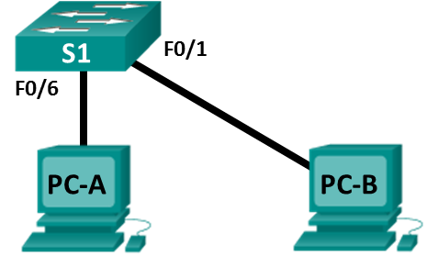

Addressing Table

|  |  |  |  |
| --- | --- | --- | --- |
| Device | Interface | IP Address | Subnet Mask |
| PC-A | NIC | 192.168.1.10 | 255.255.255.0 |
| PC-B | NIC | 192.168.1.11 | 255.255.255.0 |

Objectives

Part 1: Set Up the Network Topology (Ethernet only)

* Identify cables and ports for use in the network.
* Cable a physical lab topology.

Part 2: Configure PC Hosts

* Enter static IP address information on the LAN interface of the hosts.
* Verify that PCs can communicate using the **ping** utility.

Background / Scenario

Networks are constructed of three major components: hosts, switches, and routers. In this lab, you will build a simple network with two hosts and a switch. You will apply IP addressing for this lab to the PCs to enable communication between these two devices. Use the **ping** utility to verify connectivity.

**Note**: The switches used are Cisco Catalyst 2960s with Cisco IOS Release 15.0(2) (lanbasek9 image). Other switches and Cisco IOS versions can be used.

Required Resources

* 1 Switch (Cisco 2960 with Cisco IOS Release 15.0(2) lanbasek9 image or comparable)
* 2 PCs (Windows 10)
* Two Ethernet cables as shown in the topology

1. Set Up the Network Topology (Ethernet only)

In Part 1, you will cable the devices together according to the network topology.

* 1. Power on the devices.

Power on all devices in the topology. The switches do not have a power switch; they will power on as soon as you plug in the power cord.

* 1. Connect the PCs to the switch.
     1. Connect one end of an Ethernet cable to the NIC port on PC-A. Connect the other end of the cable to F0/6 on S1. After connecting the PC to the switch, you should see the light for F0/6 turn amber and then green, indicating that PC-A has been connected correctly.
     2. Connect one end of an Ethernet cable to the NIC port on PC-B. Connect the other end of the cable to F0/1 on S1. After connecting the PC to the switch, you should see the light for F0/1 turn amber and then green, indicating that the PC-B has been connected correctly.

**Step 3: Visually inspect network connections.**

After cabling the network devices, take a moment to carefully verify the connections to minimize the time required to troubleshoot network connectivity issues later.

1. Configure PC Hosts
   1. Configure static IP address information on the PCs.
      1. To configure the Network Settings on PC-A, click **Start**, then click **Settings**.

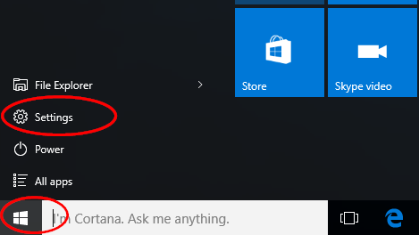

* + 1. In the Settings window click **Network & Internet**.

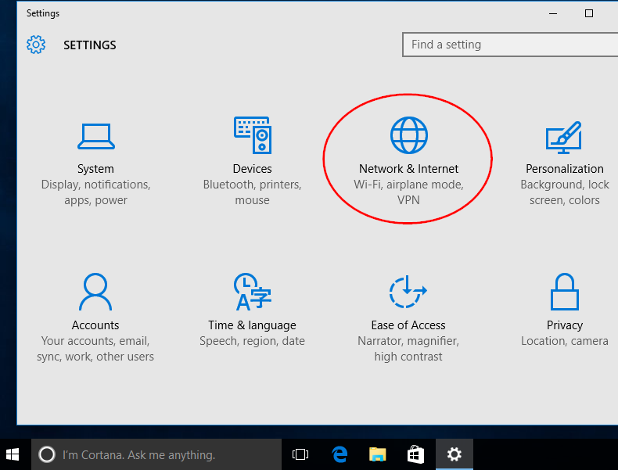

* + 1. In the left pane select **Ethernet**, then click **Change adapter options**.

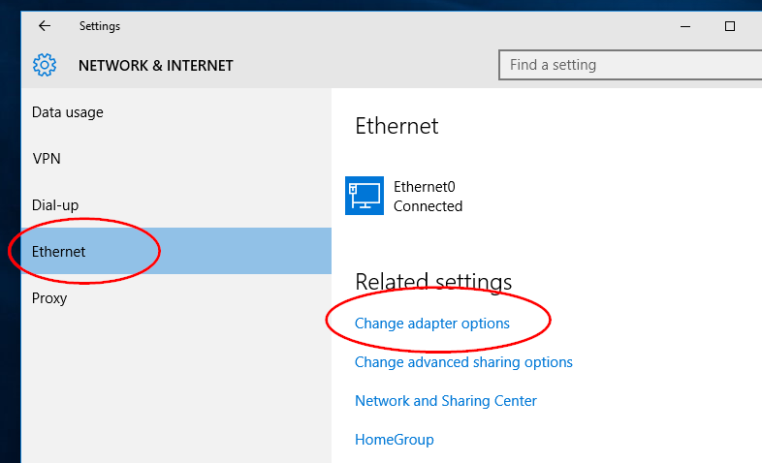

* + 1. The Network Connections window displays the available network interfaces on the PC. Right-click the **Ethernet0** interface and select **Properties**.

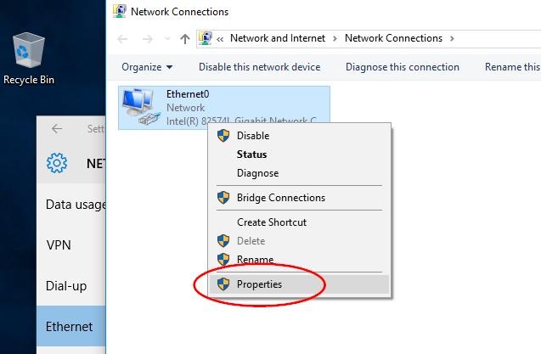

* + 1. Select the **Internet Protocol Version 4 (TCP/IPv4)** option and then click **Properties**.

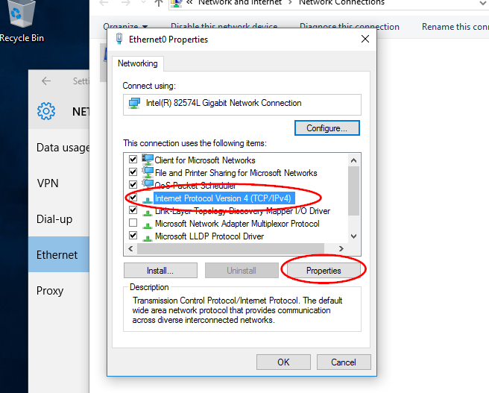

**Note**: You can also double-click **Internet Protocol Version 4 (TCP/IPv4**) to display the Properties window.

* + 1. Click the **Use the following IP address** radio button to manually enter an IP address, subnet mask, and default gateway. Type in the IP address 192.168.1.10 and the subnet mask 255.255.25.0

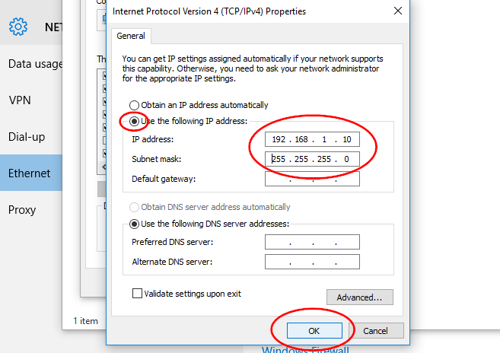

**Note**: In the above example, the IP address and subnet mask have been entered for PC-A. The default gateway has not been entered, because there is no router attached to the network. Refer to the Addressing Table on page 1 for PC-B’s IP address information.

* + 1. After all the IP information has been entered, click **OK**. Click **OK** on the Ethernet0 properties window to assign the IP address to the LAN adapter.
    2. Repeat the previous steps to enter the IP address information on PC-B.
  1. Verify PC settings and connectivity.

Use the Command Prompt to verify the PC settings and connectivity.

* + 1. From PC-A, right-click **Start**, select **Command Prompt**.

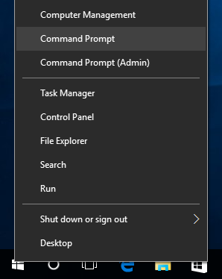

* + 1. The cmd.exe window is where you can enter commands directly to the PC and view the results of those commands. Verify your PC settings by using the **ipconfig /all** command. This command displays the PC hostname and the IPv4 address information.

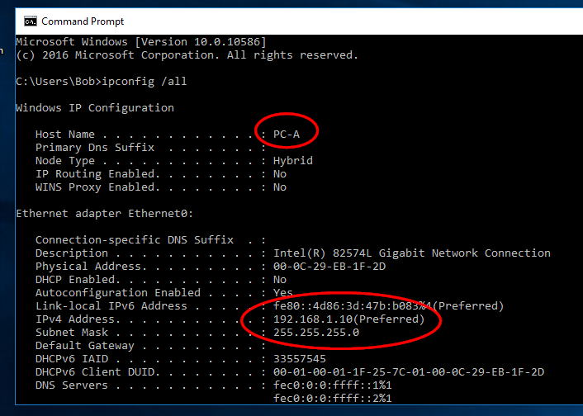

* + 1. Type **ping 192.168.1.11** and press Enter.

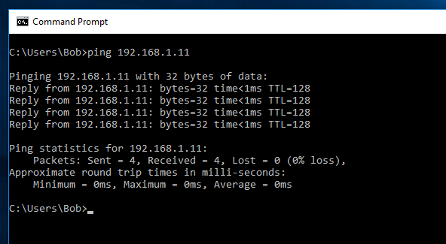

Were the ping results successful? ______________________

If not, there is good chance that **Windows Firewall** is blocking ICMP echo requests (ping). Click **Start** > **Settings** > **Network & Internet** > **Ethernet** > **Windows Firewall** to turn it off.

**Note**: If you did not get a reply from PC-B, try to ping PC-B again. If you still do not get a reply from PC-B, try to ping PC-A from PC-B. If you are unable to get a reply from the remote PC, ask your instructor to help you troubleshoot the problem.